**Linux Assignment**

1. **Download the file** [**web_scraper.sh**](https://hs2solutions-my.sharepoint.com/:u:/g/personal/sharath_ram_bounteous_com/EVjtybZVxKRHjRNAwDkxVIYB_IKgcXaEGaAEjgcYAnTC1Q?e=MwOOxC) **. Make the file executable. The file takes any  wikipedia webpage as an argument. Run the process on multiple sites like** [**Wikipedia:Stub - Wikipedia**](https://en.wikipedia.org/wiki/Wikipedia:Stub) **,** [**India - Wikipedia**](https://en.wikipedia.org/wiki/India) **at the same time**

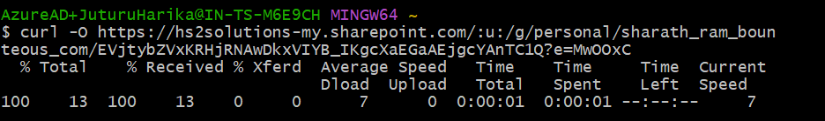

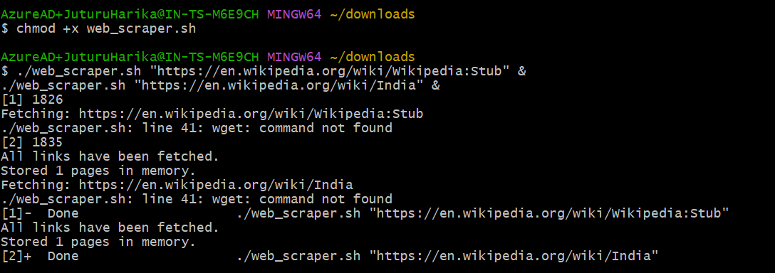

1. **Find all the processes running on the system.**

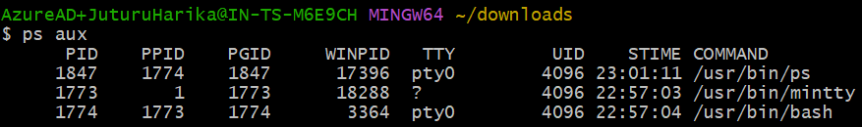

1. **Find the first 5 processes with the highest memory usage.**

Git Bash doesn’t support more functionality on ps command so used power shell instead

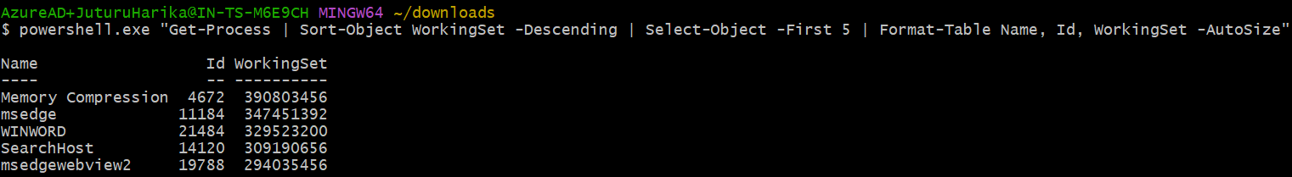

1. **Print the HTTP response code obtained from google.com.**

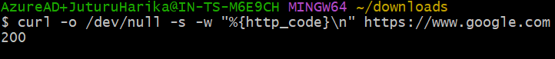

1. **Find the top 3 running processes which consume the most processing power.**

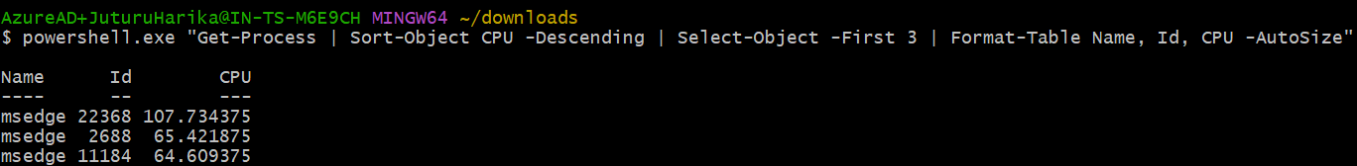

1. **Write a script that finds all files larger than 100MB in a directory and lists them**
2. **Find the python version**

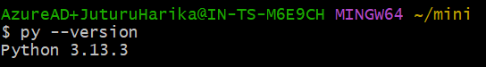

1. **Get the current time zone of your system.**

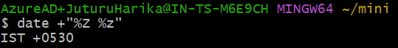

1. **Get the current time in New York, London, and Sydney.**

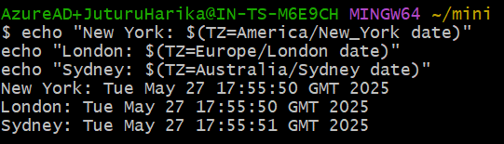

1. **Check for how long the system is up.**



1. **Given a log file:**
   1. **Find all the errors in the log and dump them to a new file.**

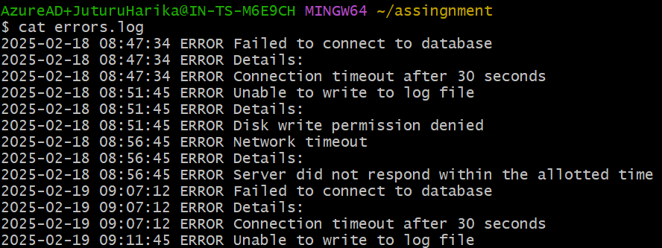

* 1. **events occurred between 09:10 and 09:19?**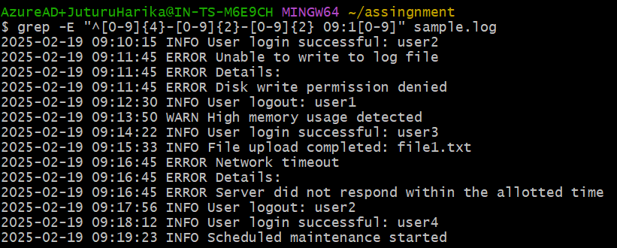
  2. **How many INFO messages are in the log file**

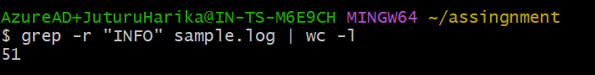

* 1. **Print the first 5 lines of the file.**

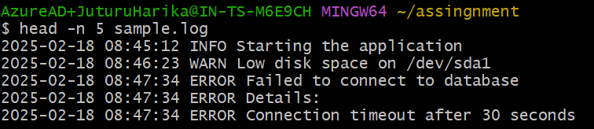

* 1. **Print lines if the lines contain error, fail, or warning.**

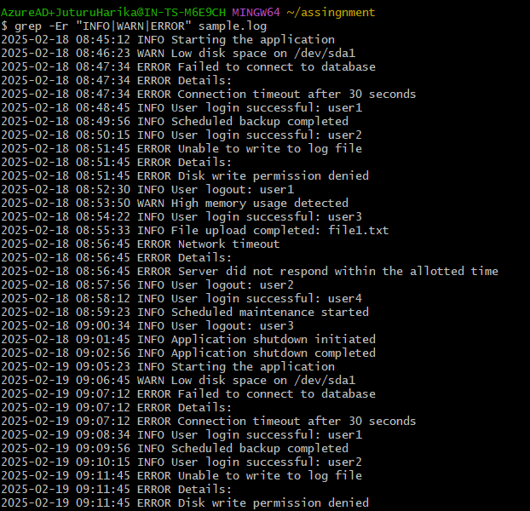

* 1. **Rename the file to new_log.txt.**

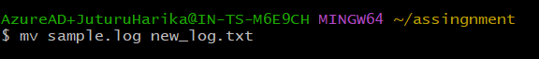

* 1. **Edit the log file and add the string "hello, world!" at the beginning of the file.**

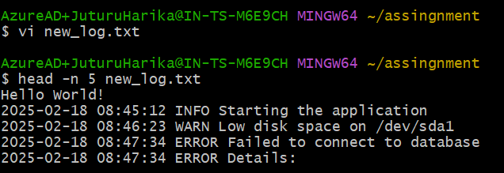

* 1. **Delete the old log file.**



* 1. **Filter entries containing the "INFO" string for a particular date for a given   log file, you can use the sample log file given below.**

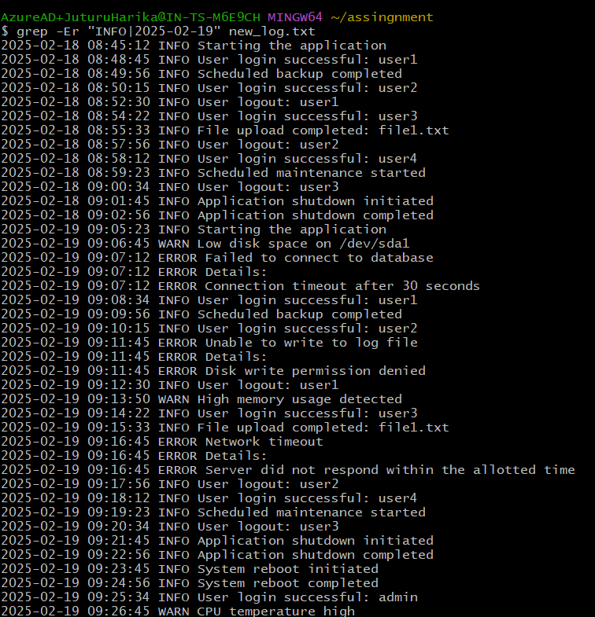

1. **Write a command to continuously monitor what is being appended to the file and output if you find the string "Error".**



1. **Connect to google.com and copy the output to a text file.**

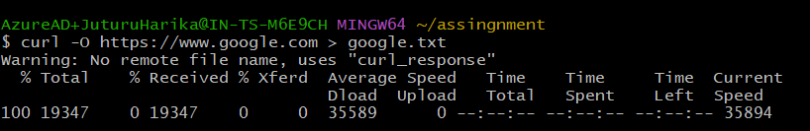

1. **Create a file called example.txt. Write a script to make it read-only for all users.**

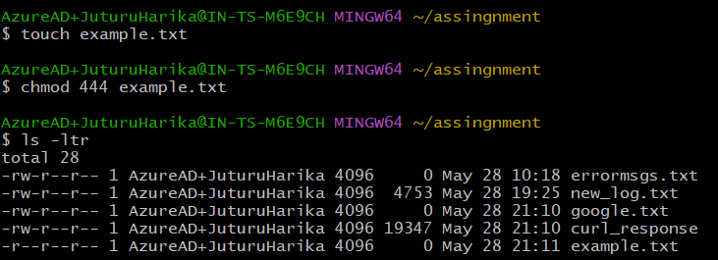

1. **Write a script that changes the permissions of a script named myscript.sh to make it executable by the owner, group, and others.**

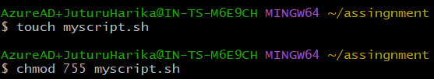

1. **Recursively make all the files readable in a directory.**



1. **List out all the files that end with ".log" in a directory.**



1. **Write a command to get the kernel version.**



1. **Find the IP address of the system.**

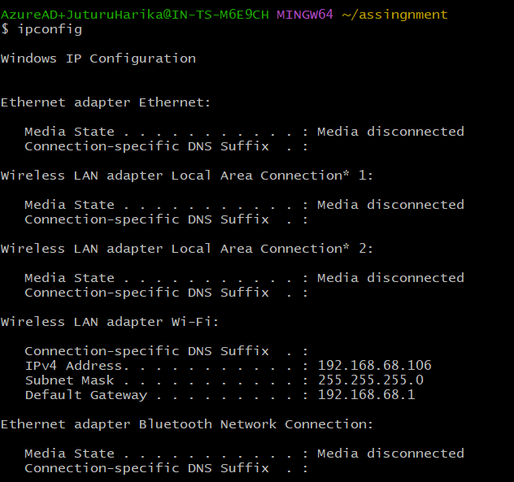

1. **Write a script to list all files and directories in the current directory, sorted by size**

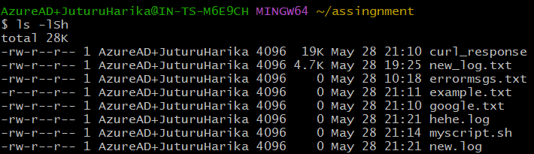

1. **List all files and directories in the current directory with sizes in human-readable format.**

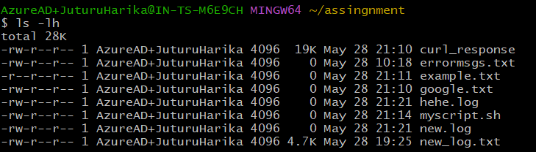

1. **Print the hostname a computer**



1. **Command to Kill a particular process running in your system.**

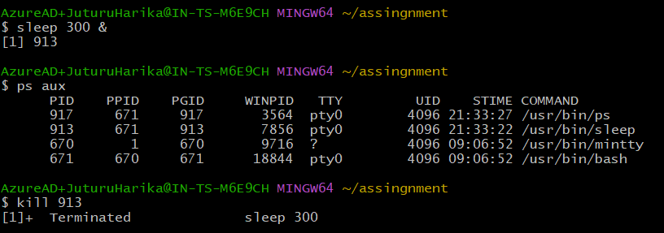

1. **Create two files test1.txt and test2.txt with some content and merge it to a single file test.text**

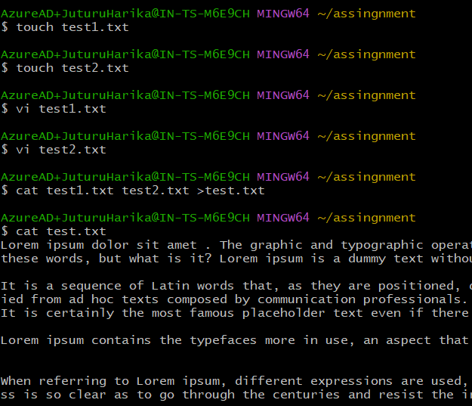

1. **Create a shell script test.sh with the content given at the bottom and execute it.**

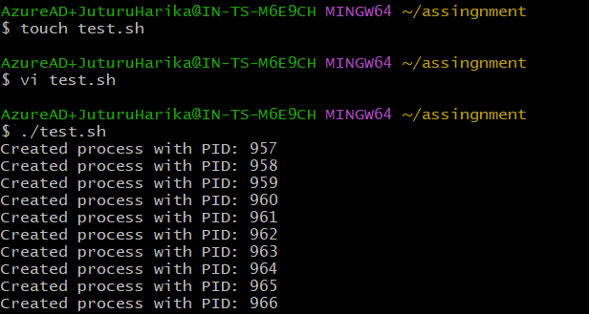

1. **Tes.sh creates mutiple process , wrtie command to kill some specific process with given pid.**



1. **Write a shell script which take your name as input and it will dispaly Hello your name.**

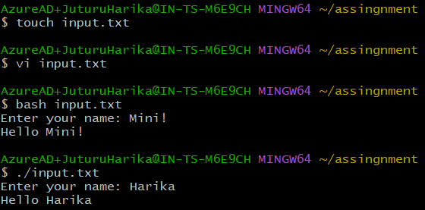



1. **Write a command to download file.zip from** [**https://github.com/github/gitignore/archive/refs/heads/main.zip**](https://github.com/github/gitignore/archive/refs/heads/main.zip)

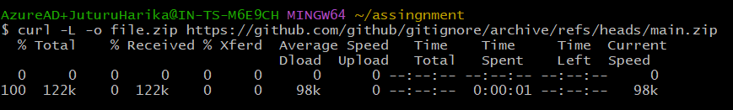

1. **Write a command to zip test.txt to test.zip and unzip it.**

